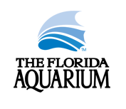
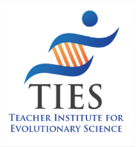
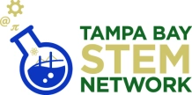
Darwin Day
Teacher Workshop Agenda
Saturday, February 11th, 2023
9:00am – 3:00pm
Vinik A & B at Florida Aquarium

The Teacher Institute for Evolutionary Science
in collaboration with
The Florida Aquarium and Tampa Bay STEM Network
presents: Evolution for Educators
8:30-9:00 | Sign-in, Bell Ringer, and  Group Selection (pun intended)
9:00-9:05 | Welcome & Introductions | Kenny Coogan  TIES Associate  And  ANYONE ELSE? FL Aquarium? / Larry?/ Marjorie?
9:05-9:50 | Part 1- The TIES Classroom Presentation  Includes:  - What is TIES?  - Your Florida State Standards on Evolution  - Introducing TIES content and resources | Our classroom presentation is designed to guide a teacher through all the state’s standards. It is NOT meant to be used as a lecture, but rather a way of staying organized. The notes section of the PowerPoint is full of active learning ideas.
9:50-10:00 | Break
10:00-11:20 | Part 1- The TIES Classroom Presentation (cont.)  Explore some of the free resources that help address misconceptions, natural selection, artificial selection and more!  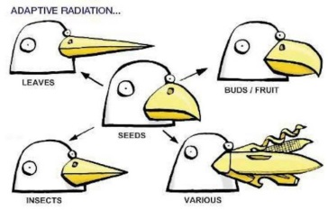  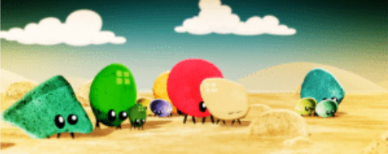
11:20-11:50 | 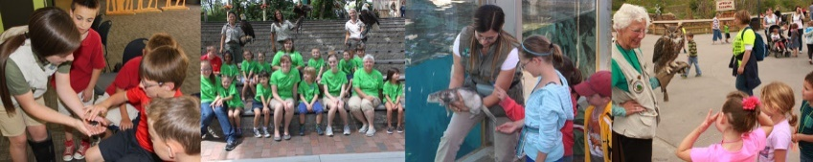  Animal Ambassador Program | Florida Aquarium
11:50-12:30 | Lunch  Provided by TIES and Tampa Bay STEM Network
12:30-1:30 | Station Rotation on Evidence for Evolution  Participants will spend 10 minutes at 6 different stations:  A. Law of Superposition B. Convergent Evolution: Carnivorous Plants: Ted-Ed C. Homologous & Vestigial Structures  - TIES Time Macine - NOVA Evolution Lab - DNA Comparison
1:30-2:30 | 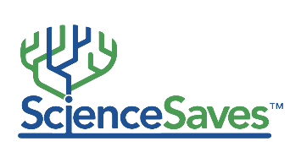  ScienceSaves and Skull Comparison Lab  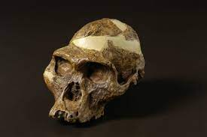  Presented by TIES Director Bertha Vazquez
2:30-3:00 | FL Aquarium Announcements, Raffles, and Door Prizes for all.
3:00-5:00 | Tour the Aquarium
Thank you! Kenny Coogan, TIES Associate
